**Ex.No:11B**

**Date:24.10.24**

# ARITHMETIC OPERATIONS USING RPC

**AIM:**

To Develop a simple calculator using XMLRPC

.

**ALGORITHM:**

**Server.py**

1. Import XMLRPCServer package
2. Define functions for addition, subtraction, multiplication, division and modulus
3. Initialize simple XMLRPCServer with IP address (or localhost) and port number
4. Register the functions add, sub, mul, div and mod with the server
5. Handle the request
6. Close the connection

**Client.py**

1. Import XMLRPC Client package
2. Define functions for addition, subtraction, multiplication, division and modulus
3. Initialize simple XMLRPC Client with Server IP address (or localhost) and port number
4. Get two numbers a and b for arithmetic operations
5. Call add() function and print the result
6. Call sub() function and print the result
7. Call mul() function and print the result
8. Call div() function and print the result
9. Call mod() function and print the result
10. Close the connection

**CODE:**

**Server.py**

XML RPC PROGRAM- SERVER SIDE:

from xmlrpc.server import SimpleXMLRPCServer

# Define a function def is_even(n): return n % 2 == 0 def add(a,b): return a+b def sub(a,b): return ab def factorial(n): factorial=1 for i in range(1,n+1): factorial = factorial*i return factorial def multiply(x, y): return x * y def divide(x, y):

return x // y

# Create server

server = SimpleXMLRPCServer(("localhost", 8000))

print("Listening on port 8000...")

# Register a function under a different name server.register_function(is_even, "is_even") server.register_function(add, "add") server.register_function(sub, "sub") server.register_function(factorial,"factorial")

#server.register_function(factorial,"factorial") server.register_function(multiply, 'multiply') server.register_function(divide, 'divide')

# Run the server's main loop server.serve_forever()

**Output:**

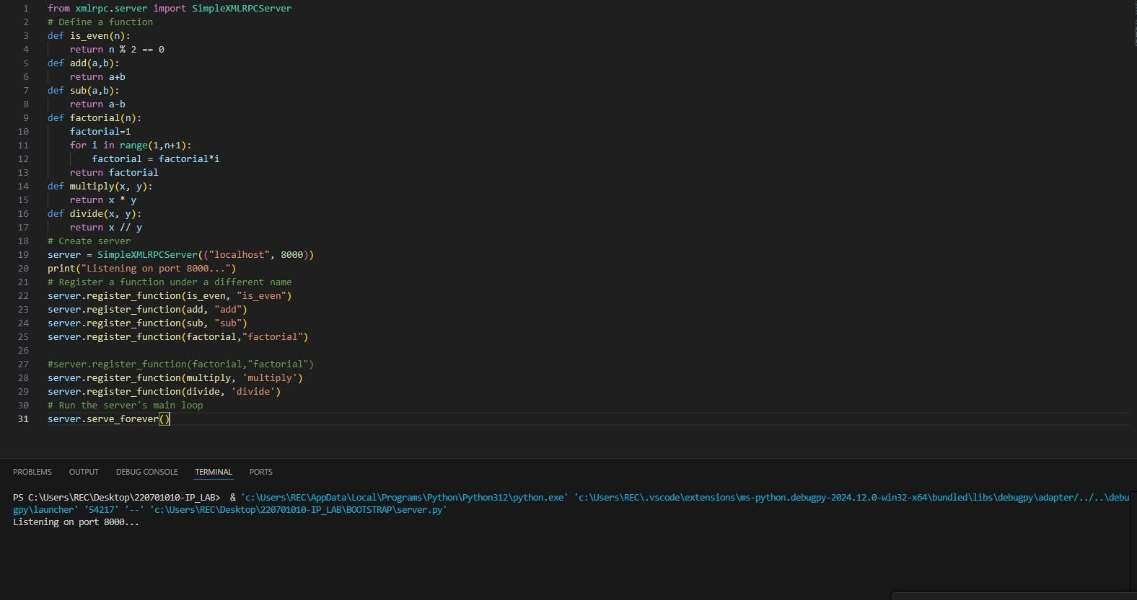

**Client.py**

XML RPC PROGRAM- CLIENT SIDE:

import xmlrpc.client proxy= xmlrpc.client.ServerProxy('http://localhost:8000/') # local server for i in range(5): a=int(input("Enter a number:")) b=int(input("Enter

b number:"))

print("%d is even?: %d" % (a, (proxy.is_even(a)))) #access XML-RPC server through proxy

print("addition of given number is %d "%((proxy.add(a,b)))) print("sub of given number is

%d "%((proxy.sub(a,b)))) print("factorial: %d" %((proxy.factorial(a)))) print("factorial: %d"

%((proxy.factorial(b)))) print(“Multiplication of 2 numbers is %d” %(proxy.multiply(a,b)) print(“Division of 2 numbers is %d”

%(proxy.divide(a,b))

**Output:**

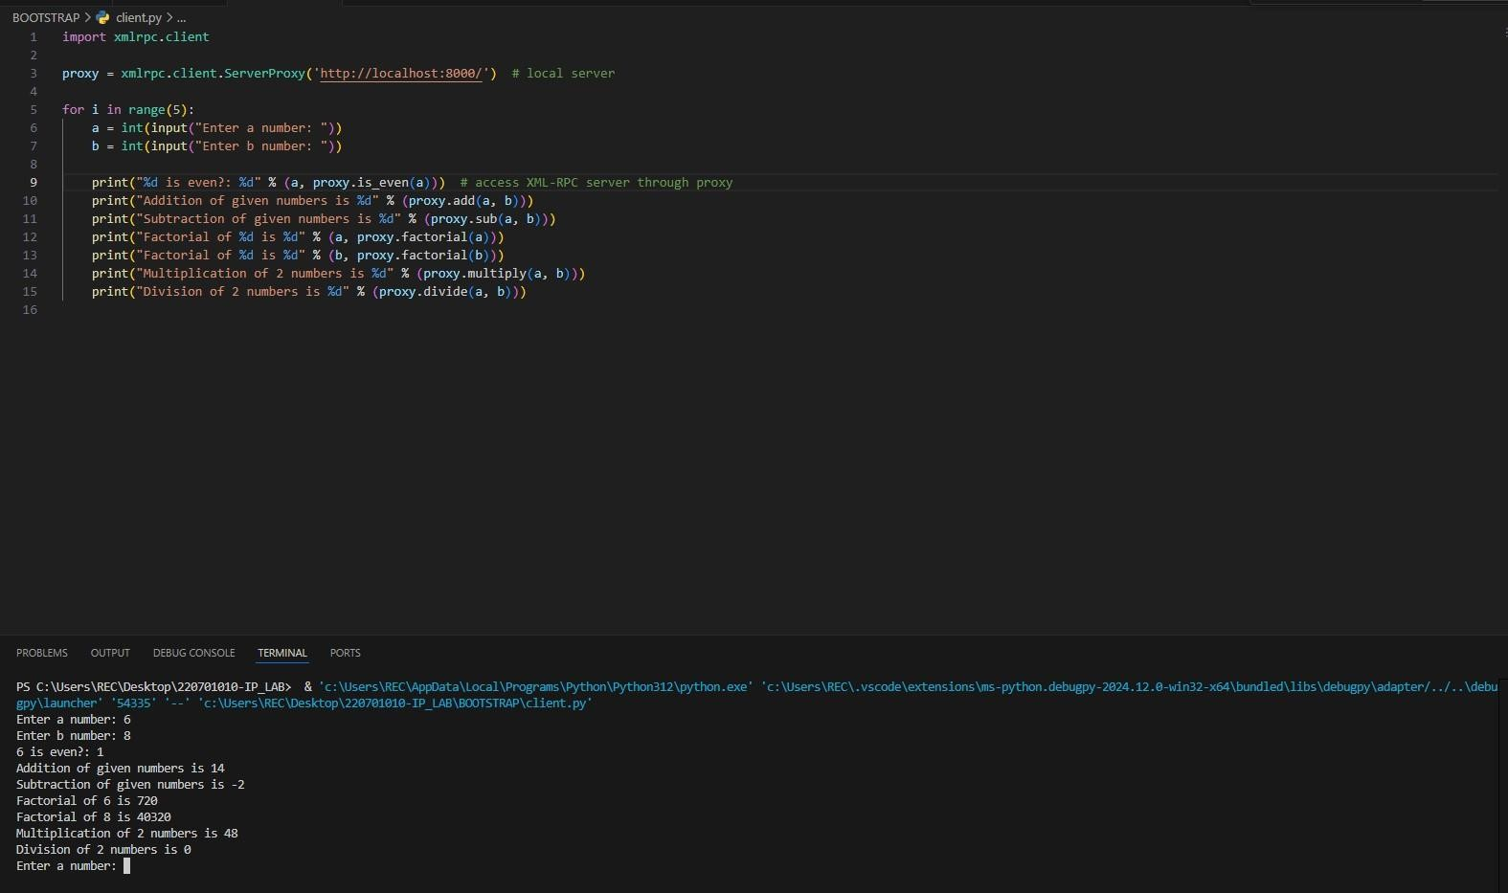

**Result:**

A simple calculator was designed using XMLRPC.